MODULE END ASSIGNMENT:

Data Cleaning, Analysis & Visualization with Excel

NAME :- HARITHA HARI
Batch :-DA69

QUESTION AND EXPANATIONS WITH SCREENSHOT
- Data entry, import, and basic organization using tables

ANS :--
To bring a dataset from GitHub into Excel, First locate the repository containing the dataset and open the raw file. Then download the file .
In excel go to Data Get data Form File Form Text/CSV and select the corresponding downloaded dataset.
To create table go to Insert Table. From this table we can sort ,filter and analyze the data easly.
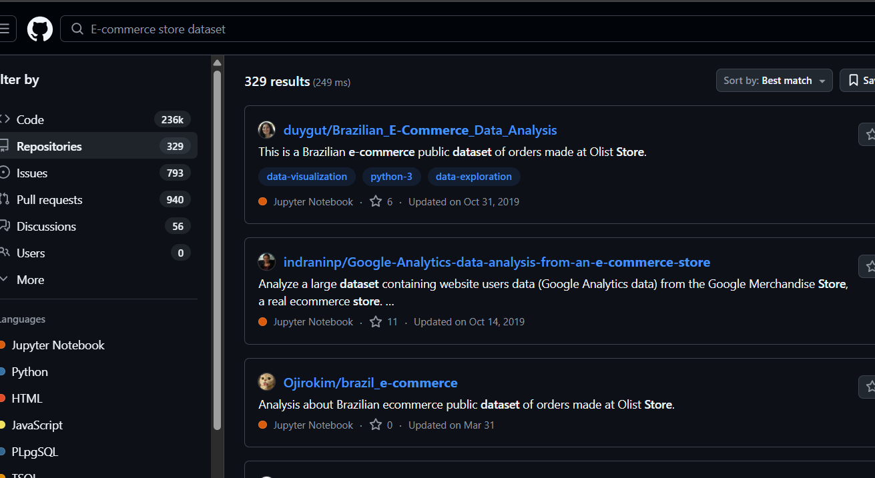
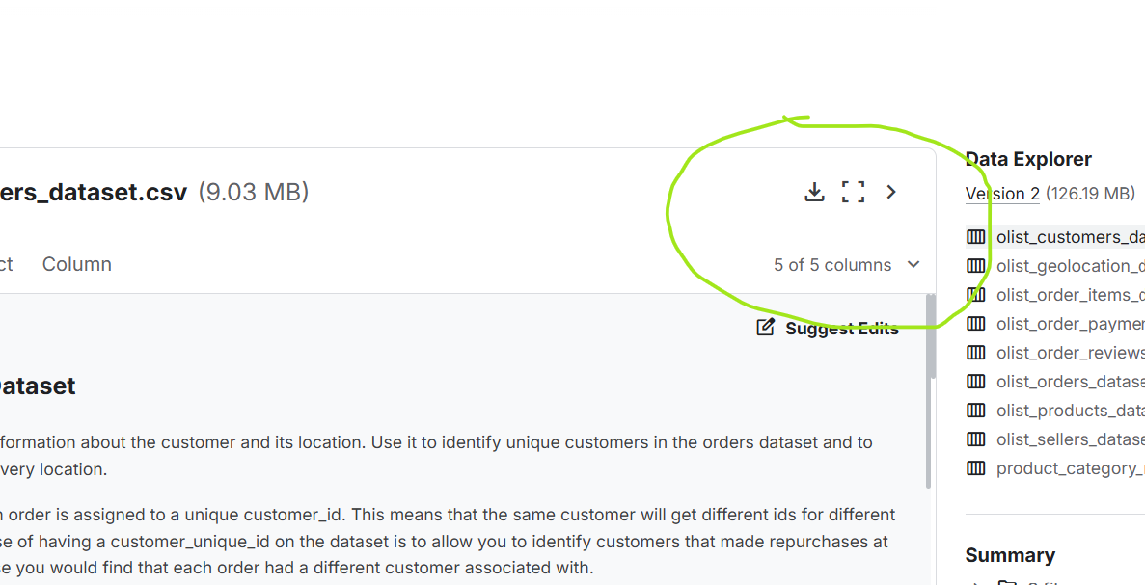
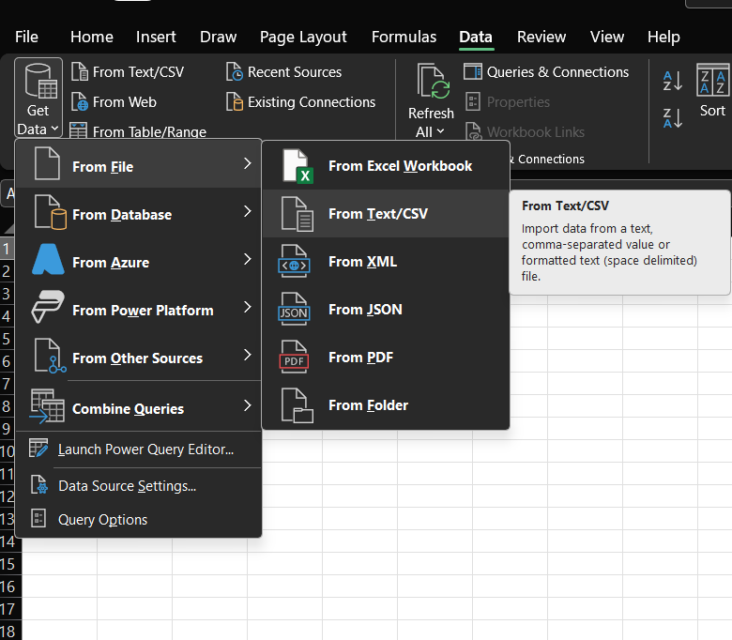
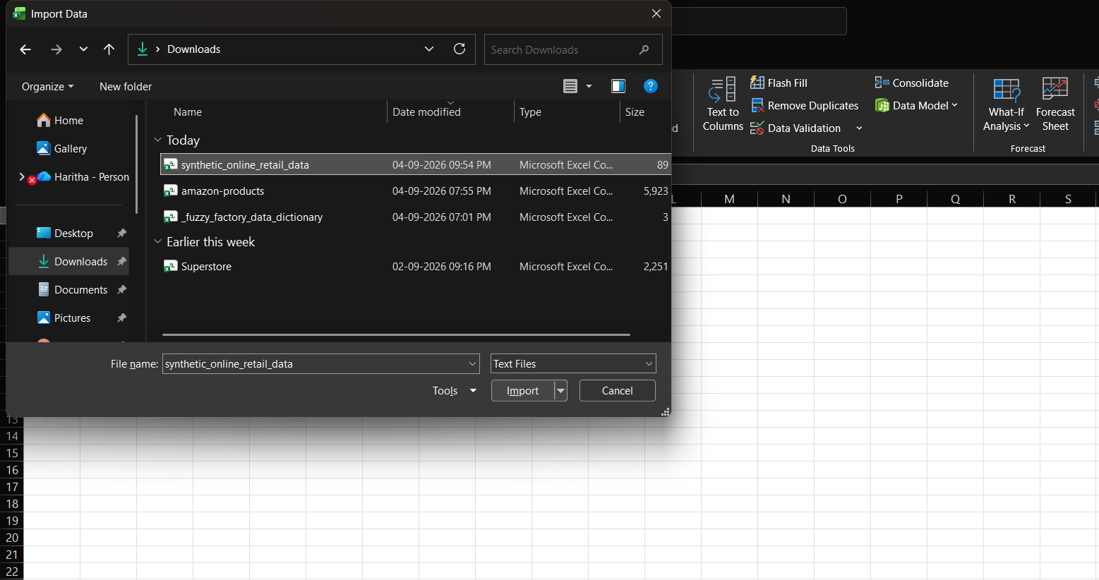
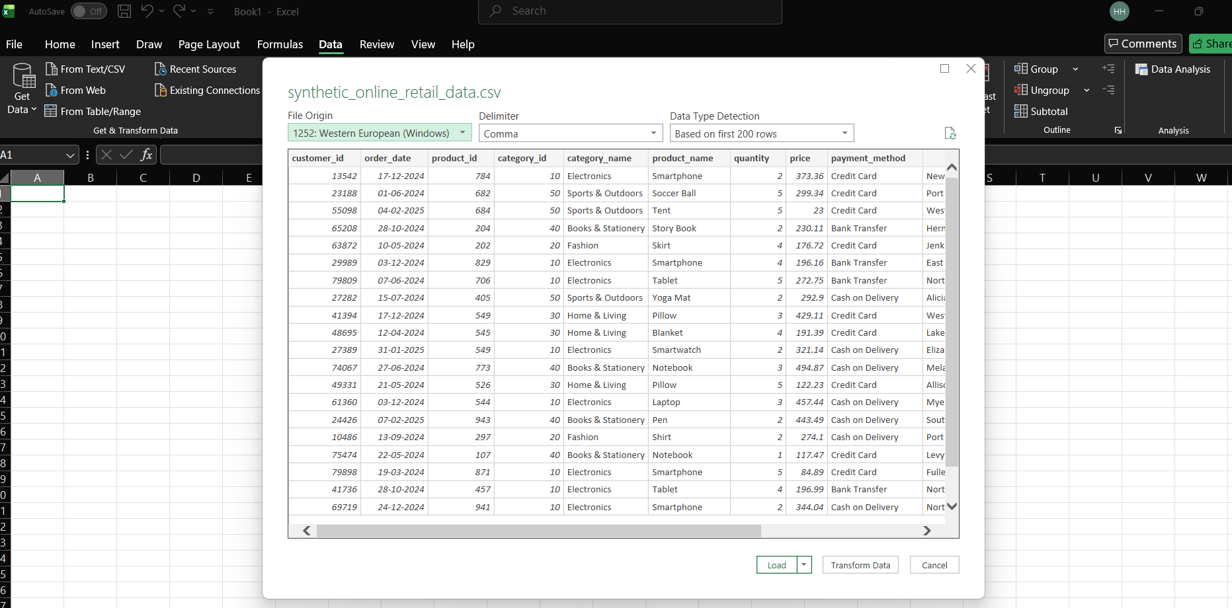
CREATE TABLE:
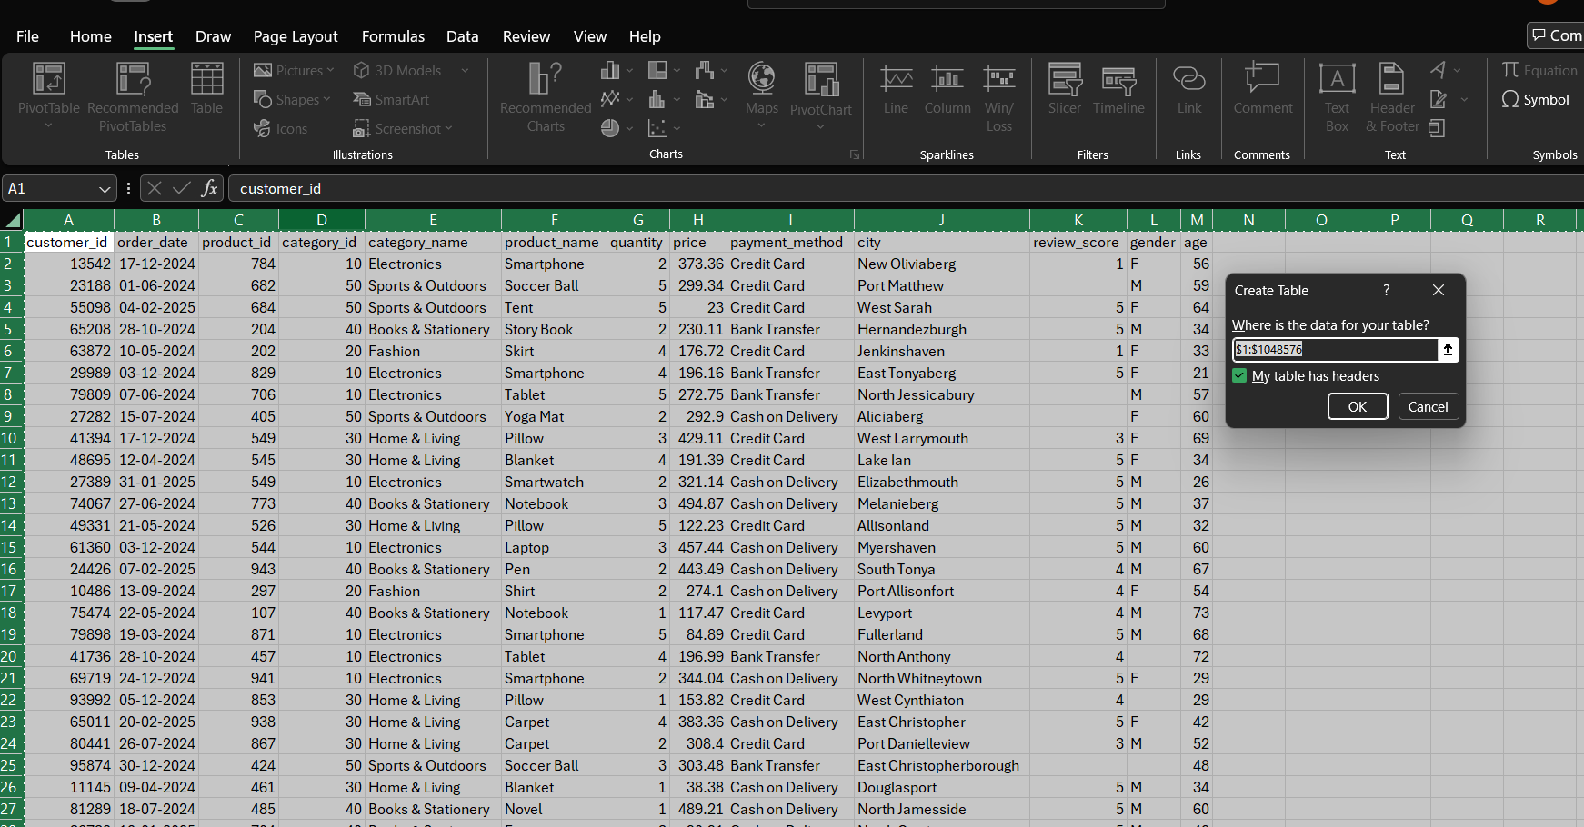
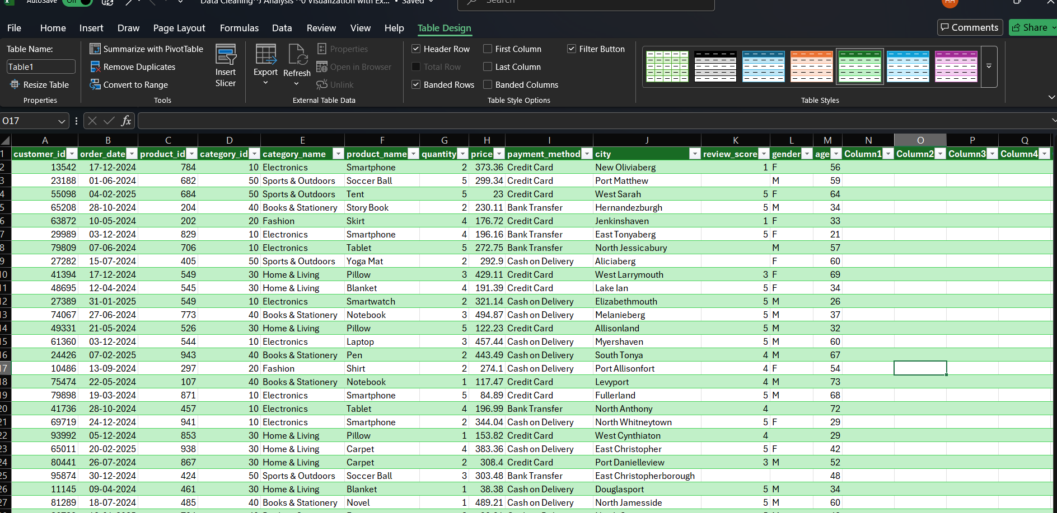

- Data cleaning: find/remove duplicates, handle missing/inconsistent data, correct formatting errors, and validate data

ANS :--

Remove Duplicates:
The editing is done by the power query editor, this will handle a large set of data.
Firstly select the data range and the go to Home Remove raws Remove Duplicates.
This will clear or delete all the duplicate data found inside the dataset.

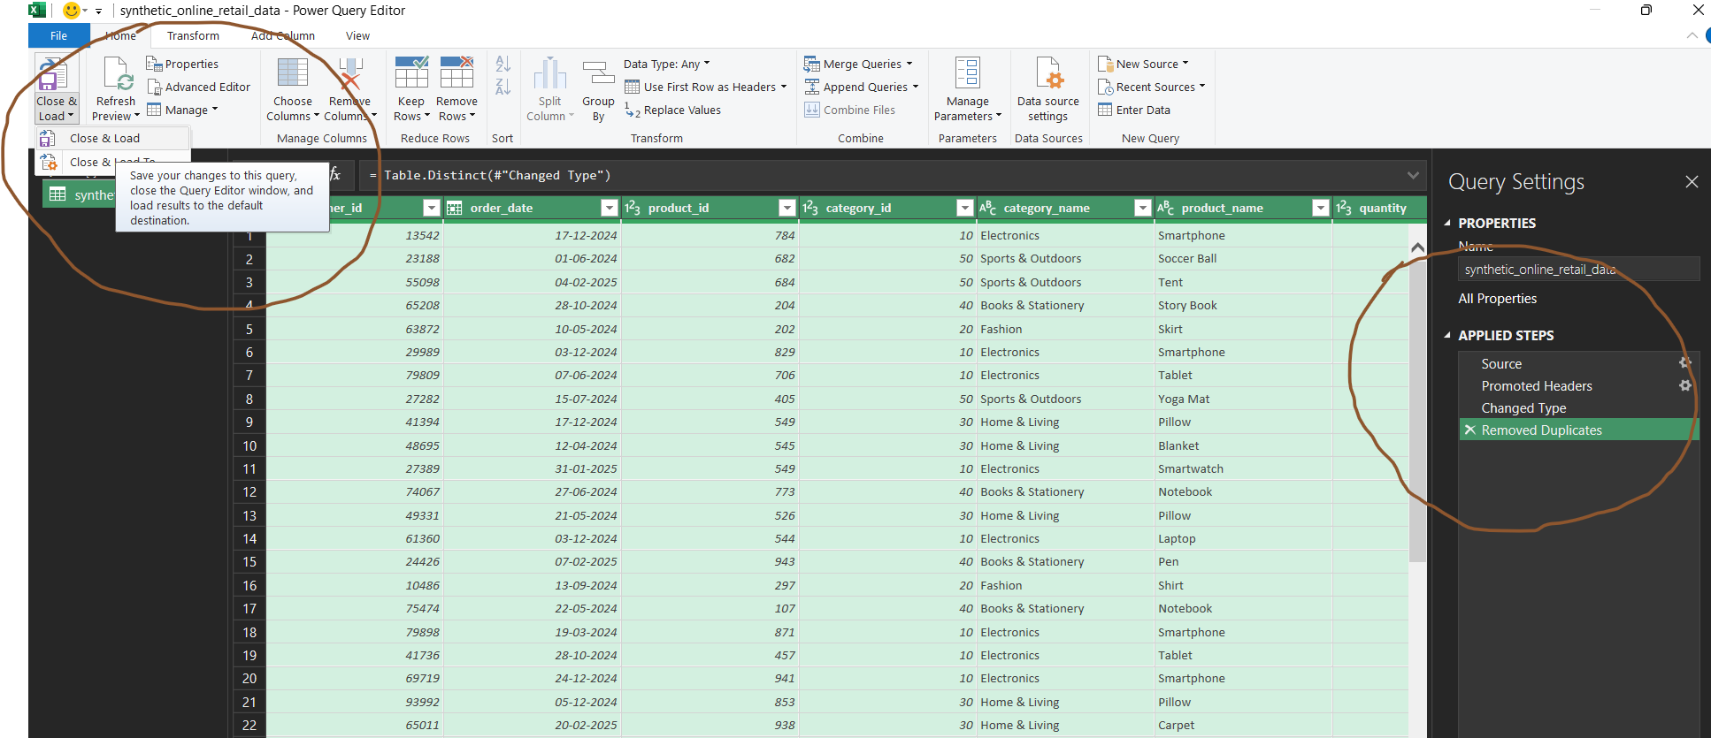

Loaded data
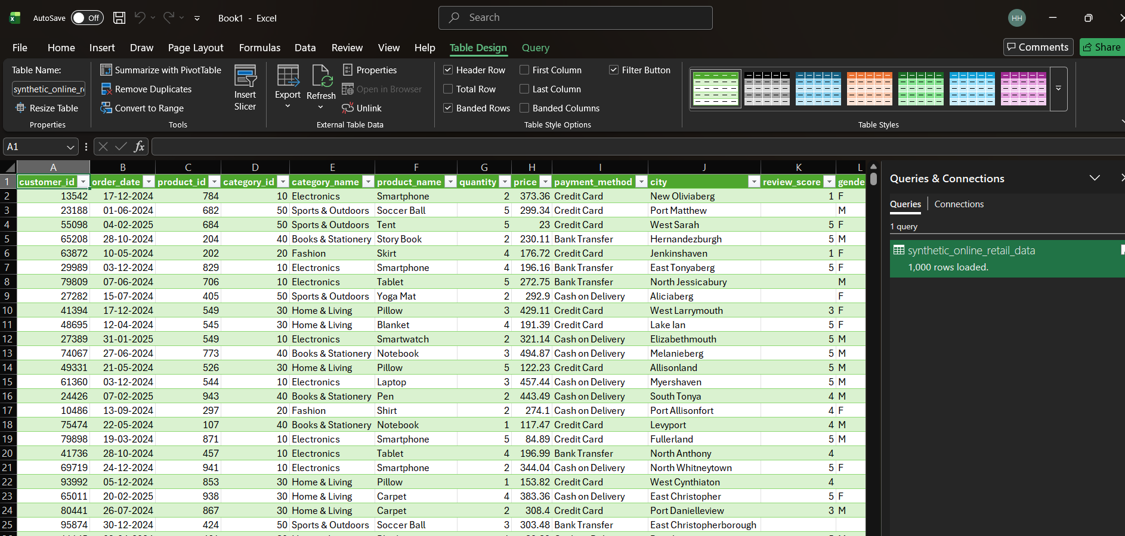

If the given data is inconsistent , we will make it into a structured manner and if there are empty columns, null value or missing value , we can find them and delete. But deleting null values is only possible for small data set. If the data set is large then we cannot delete them, instead fill them or impute them with mean or median if it is numerical value.
Suppose the data range is 1,2,5,100,180 then 100 & 180 both are outliers.
Then we will use Median as the imputation method. If there is no such outliers then we will use Mean / Average as the corresponding imputation method.
If the data is a categorical column the we can use Mode as the imputation method. Or else we will fill with a fixed value if it is known (Mostly possible for small data set). If the data is not belongs to the above mentioned type then fill them with fixed words such as “Unknown”, “NULL” etc..

In order to find inconsistency in a dataset we will use the technique called Find & Replace.
Select the data then go to Home Editing Find & Replace.

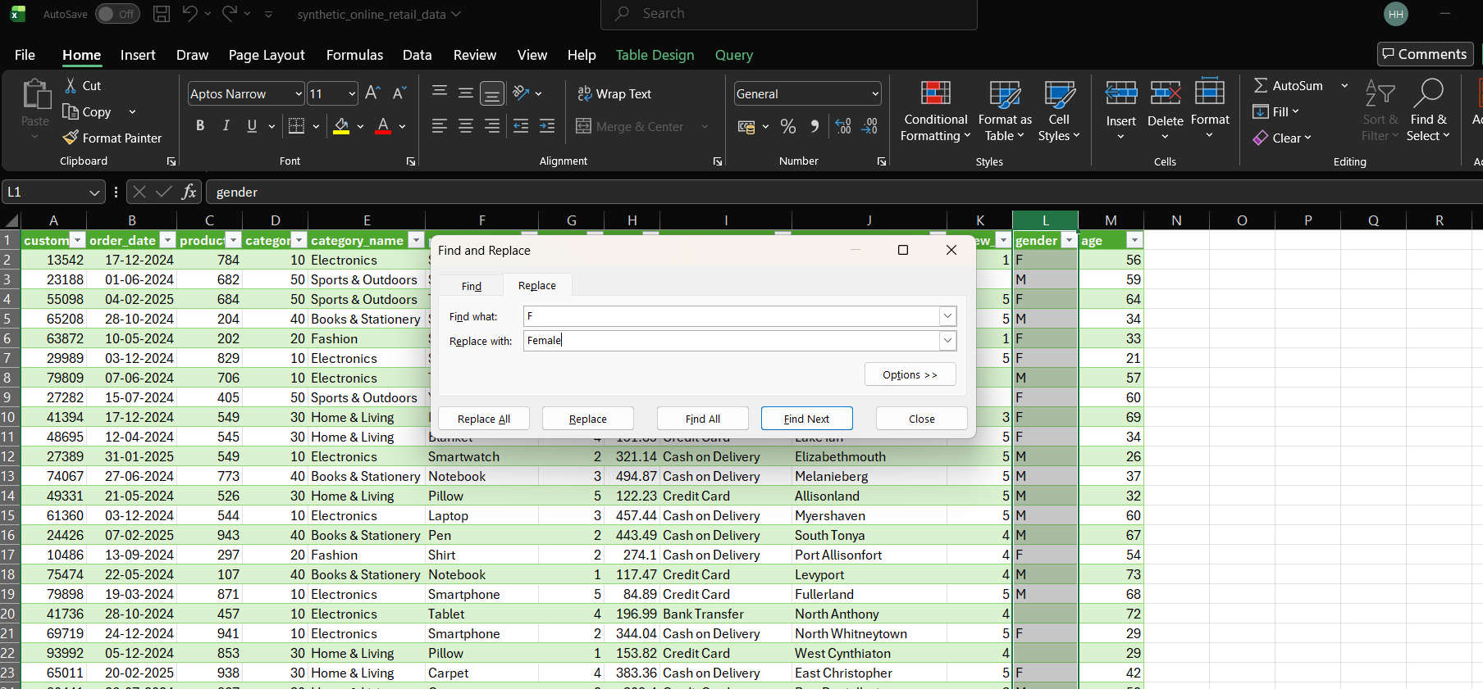

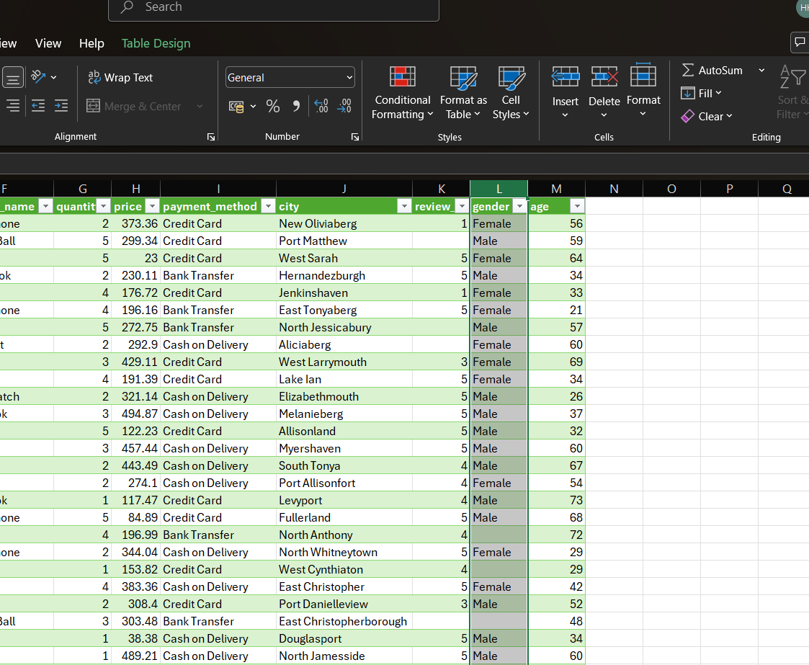

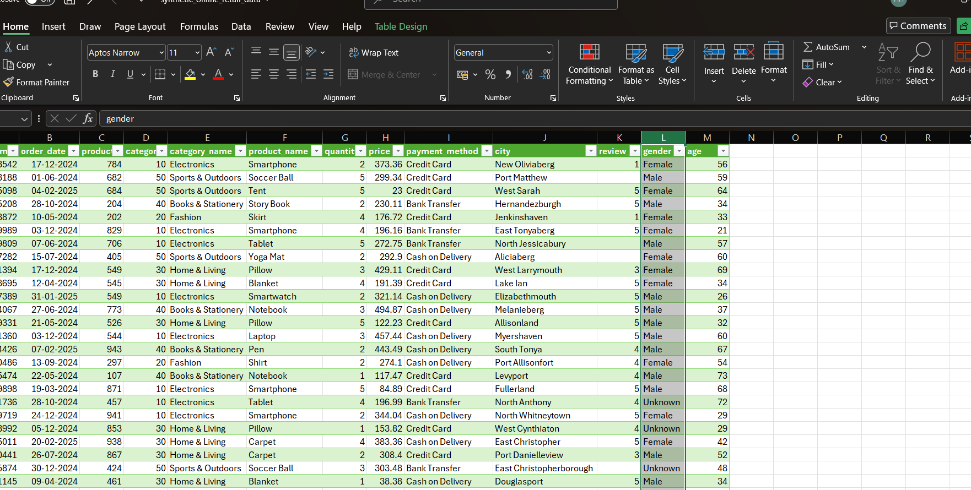

M replaced with Male
F replaced with Female
Blank space filled with Unknown.

For review we fill with the average of the reviews given by the customers since the customer id is unique and no duplicate value found in the dataset, since we have removed all the duplicate values before doing the function.

So the empty cells in review_score column is replaced by the average of the reviews.
Some times it may accurate ,it fully depends on the data, if the same customer rated multiple times then the step is invalid. Here the customer_id is unique so we can assume that the rating is approximately accurate.
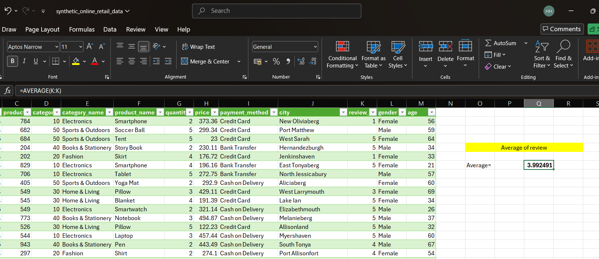

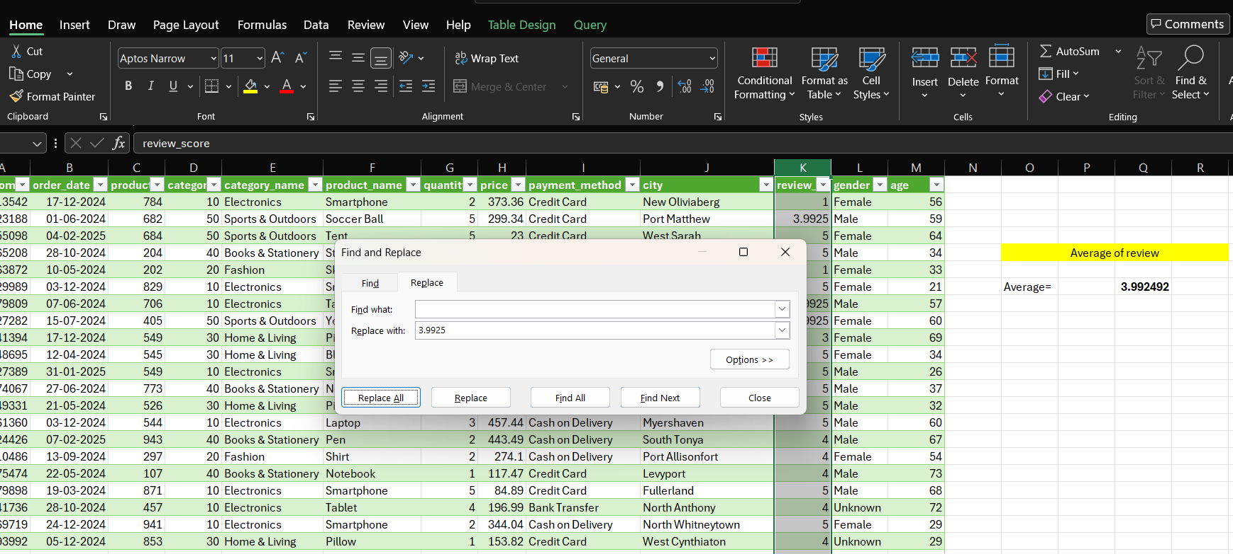

CONDITIONAL FORMATTING:
It is a powerful feature that allows to visually highlight, emphasize or apply specific formatting to cells or ranges of cells based on certain conditions.
Suppose if the clint wanted to know ,which age group is mostly using credit card purchases, For that we can use conditional formatting .
Steps : Home Styles Conditional formatting Data bars.

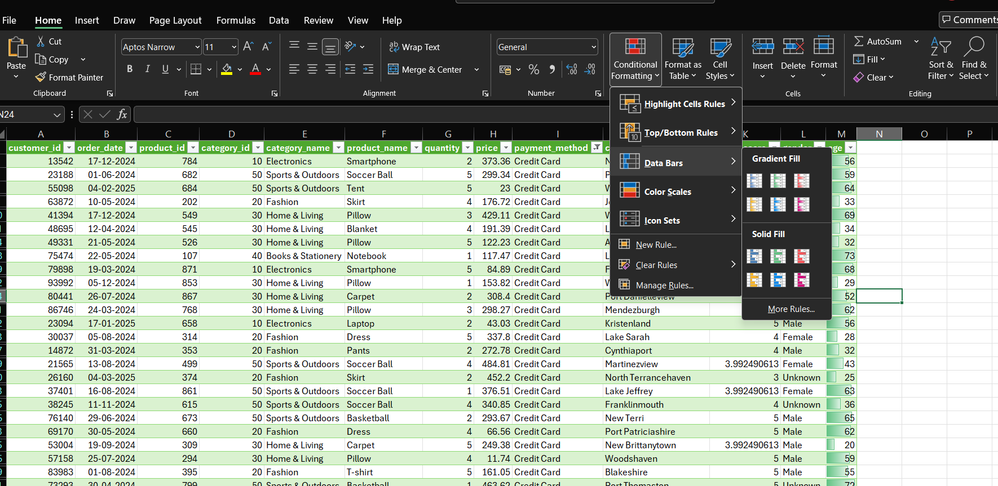
This is only for credit card users, we can filter the columns depends on the requirements.

- Remove the column which contains irrelevant data(sub_Category)
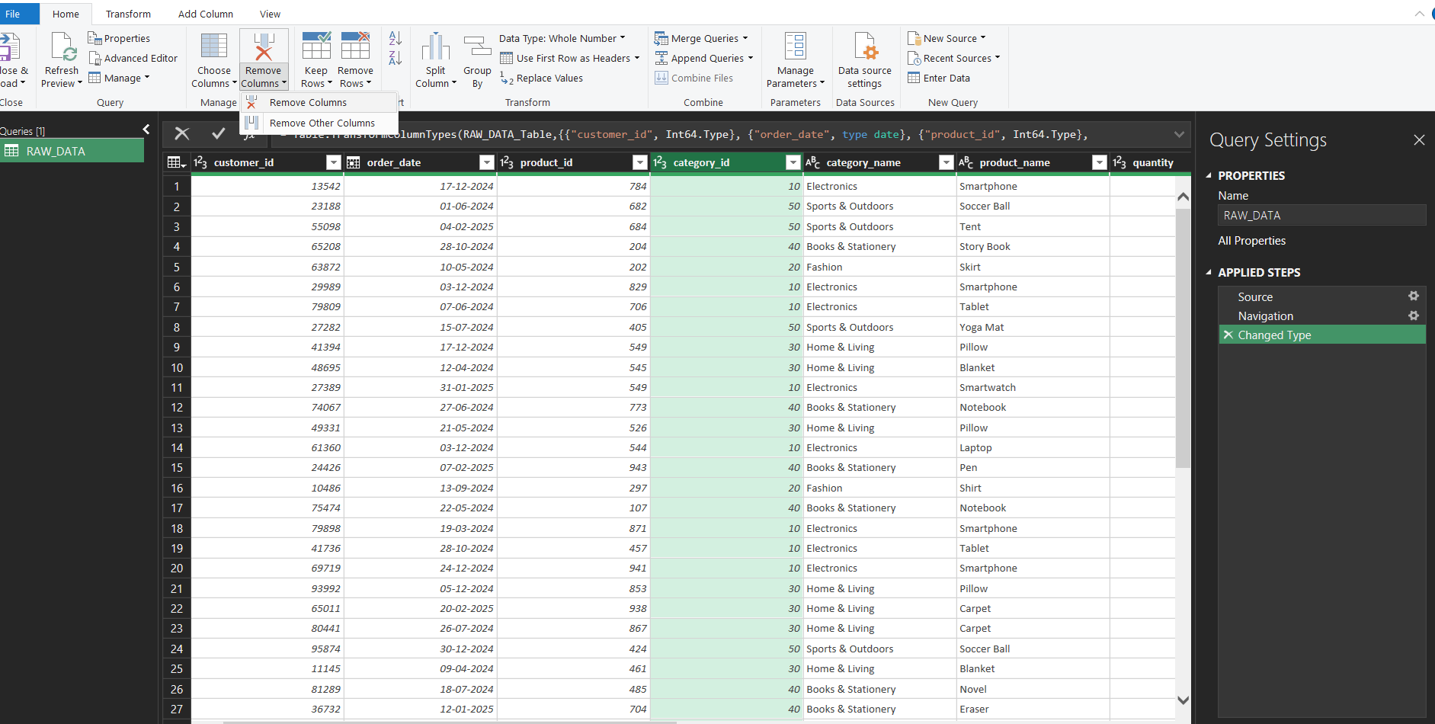
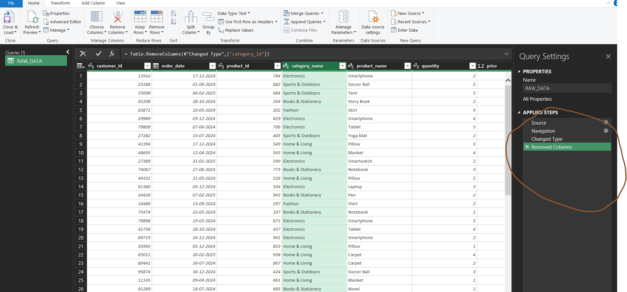
In order to remove unwanted columns , we can delete it through power query editor, First transform the data from excel to power query editor.
Steps: Data Get Data From file From excel workbook Select the File Import Select the cell Home manage columns Remove Columns Remove Columns.

- Data validation
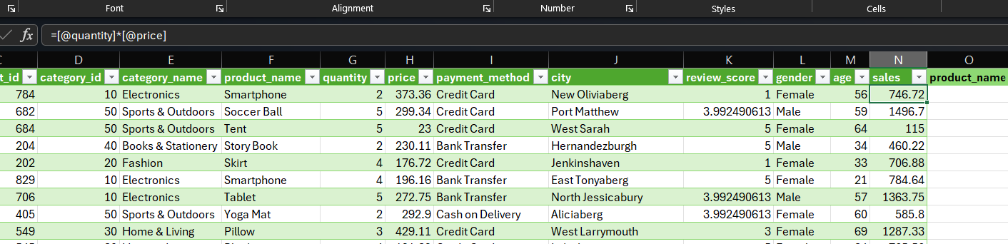

Total sales corresponding to each product is calculated using formula
=[@quantity]*[@price]
SUMIF: Here SUMIF function is used to provide the sum of the total sales to the selected colum.
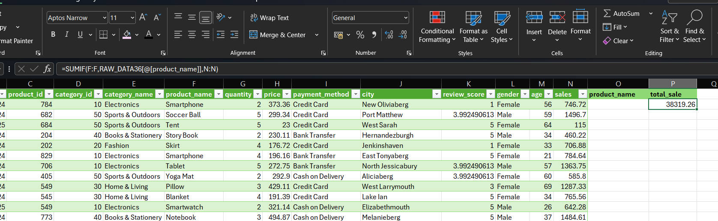
Formula : =SUMIF(F:F,RAW_DATA36[@[product_name]],N:N)

For data validation ,
Steps : Data Data tools data validation Allow List source (choose the column) Click ok.

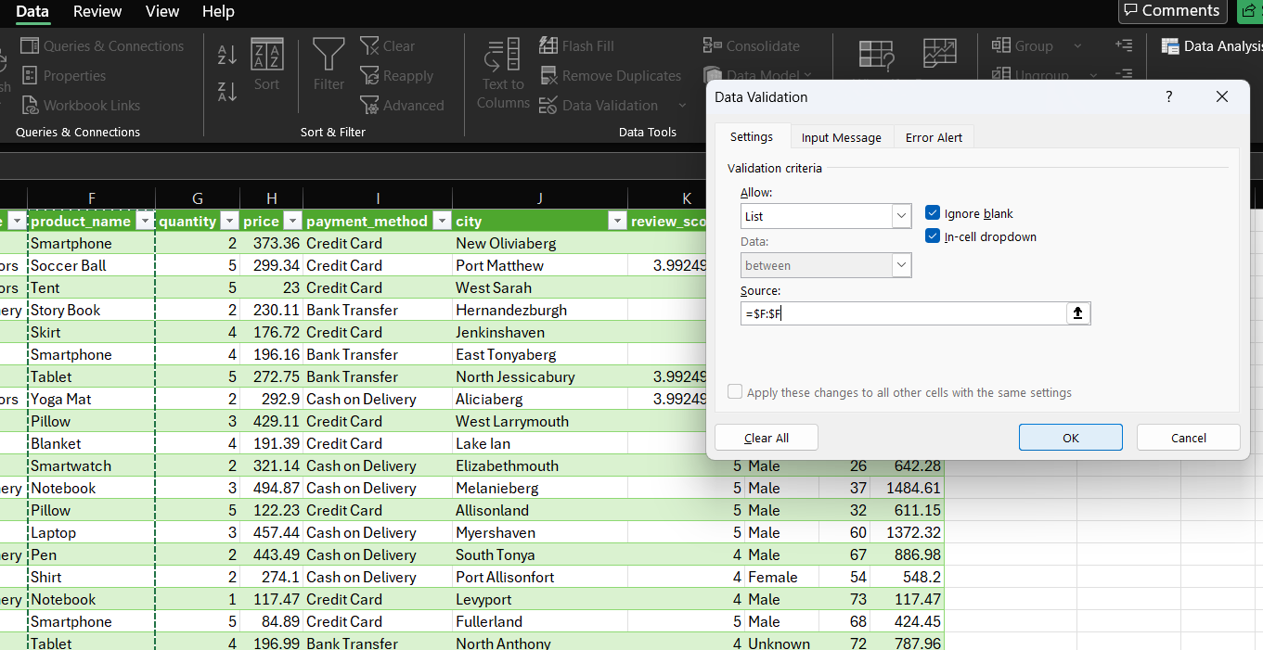

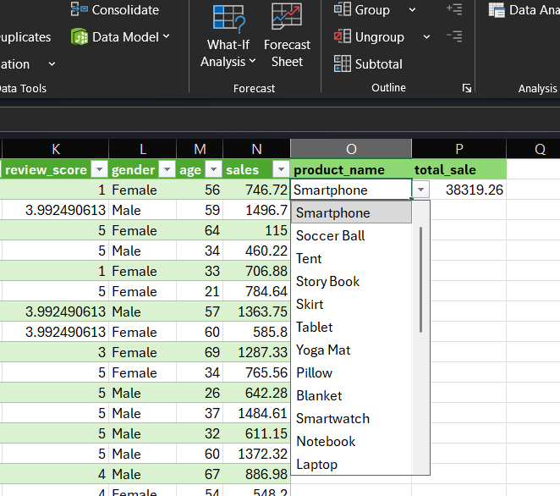

- Application of Excel formulas for calculations, summaries, and logical/text operations
SUMIF:
SUMIF function is used to sum a range of values under a condition,
Suppose the condition is add the values in a selected range where the value greater than or equal to 300, so the function will work and gives the sum of the values >= 300.
Formula: =SUMIF(H2:H27,">300")
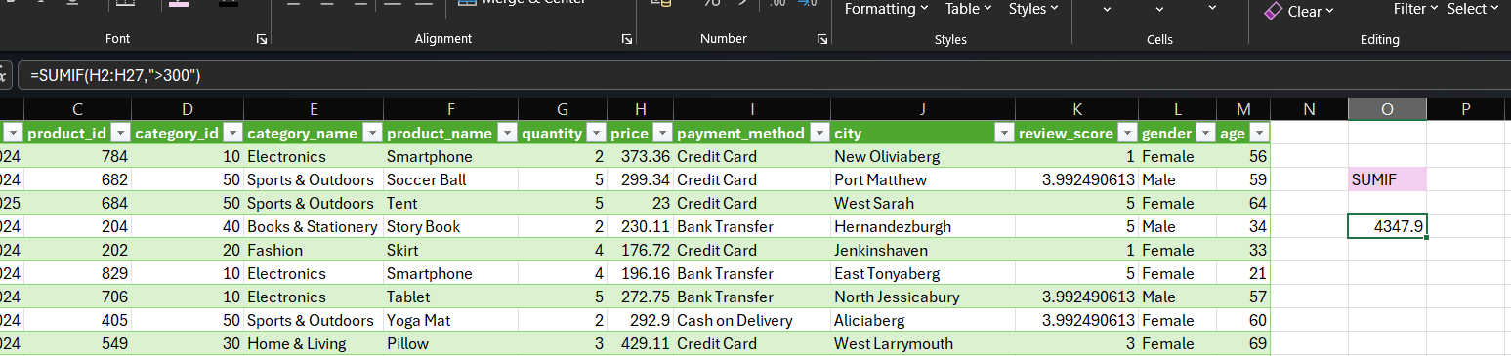

COUNTIF:
COUNTIF function is used to count a range of values under a condition,
Suppose the condition is count the values in a selected range where the value equal to 4, so the function will work and gives the count of the values =4.

Formula : =COUNTIF(G2:G28,"=4")
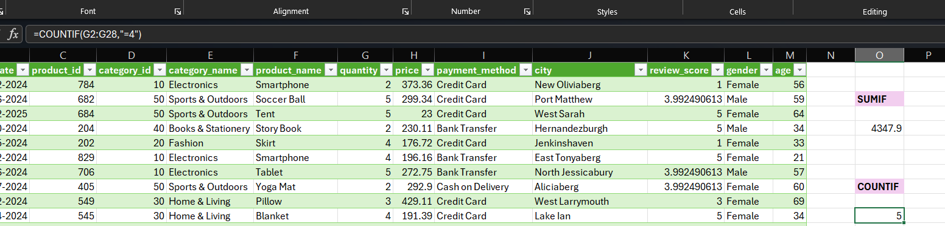

AVERAGEIF:
function is used to find the average of values under a condition.
Suppose the condition find the average of the selected range where the value >= 300, so the function will work and gives the average of the values >=300.
Formula : =AVERAGEIF(H2:H27,">=300")
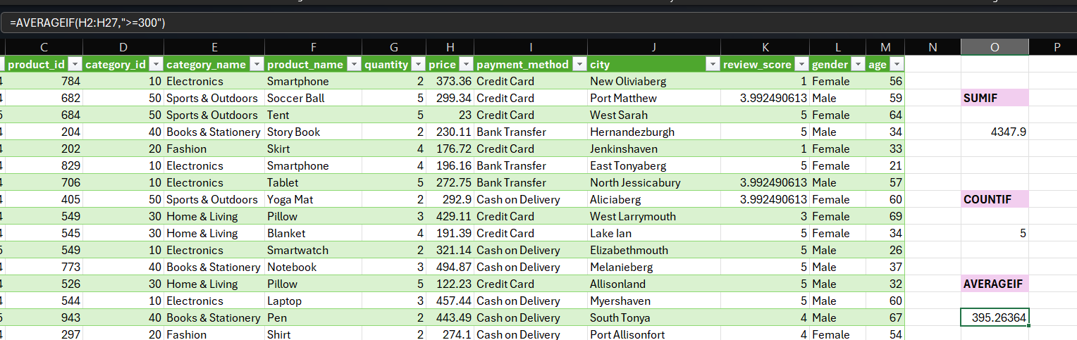
TEXT:
This function is used to find the day from a given date , suppose the given date is “17-12-2024
“ and then we can find the corresponding day from the function.

Formula: =TEXT(B2,"DDDD")

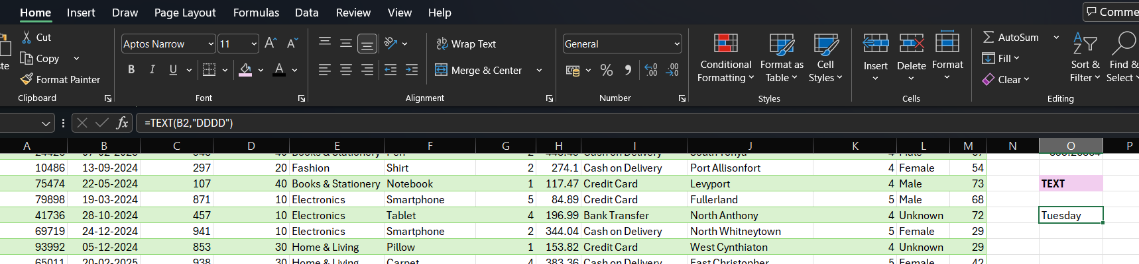

AVERAGE:
AVERAGE Function is used to find the average of a selected range of cells.
Formula: =AVERAGE(RAW_DATA37[price])

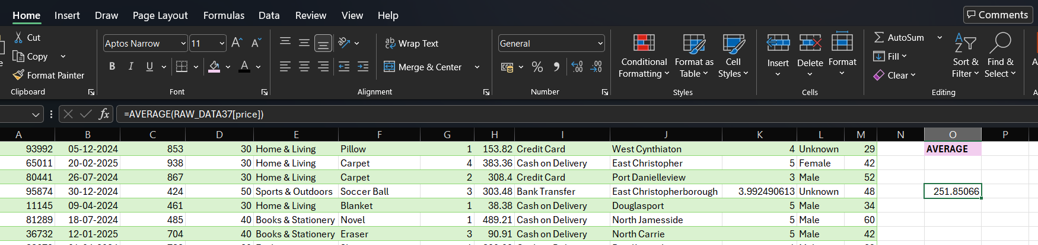

. Use the XLOOKUP/VLOOKUP functions to combine the tables.
This function searches for a specific value in the first column of a table and returns a value from another column in the same row.
Suppose if we need to find the gender of the customer and customer id is given, so use the formula,
Formula : =VLOOKUP(O31,A2:M6,12,FALSE)
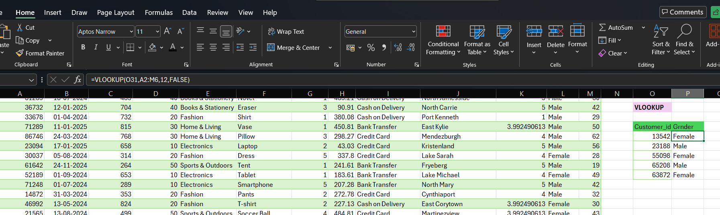

XLOOKUP:
XLOOKUP is a modern and advanced lookup function used to find values in any direction.
Suppose if wanted to know the price corresponding to a customer_id , then use this formula,
Formula : =XLOOKUP(A2,A2:A6,H2:H6)

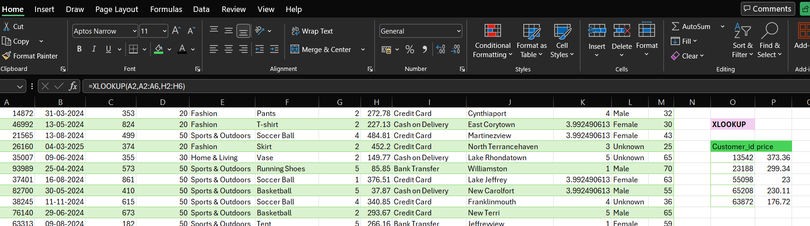
DATA ANALYSIS TOOLPACK:
- Descriptive statistics (mean, median, mode, standard deviation, etc.) using formulas or Analysis Tool Pack

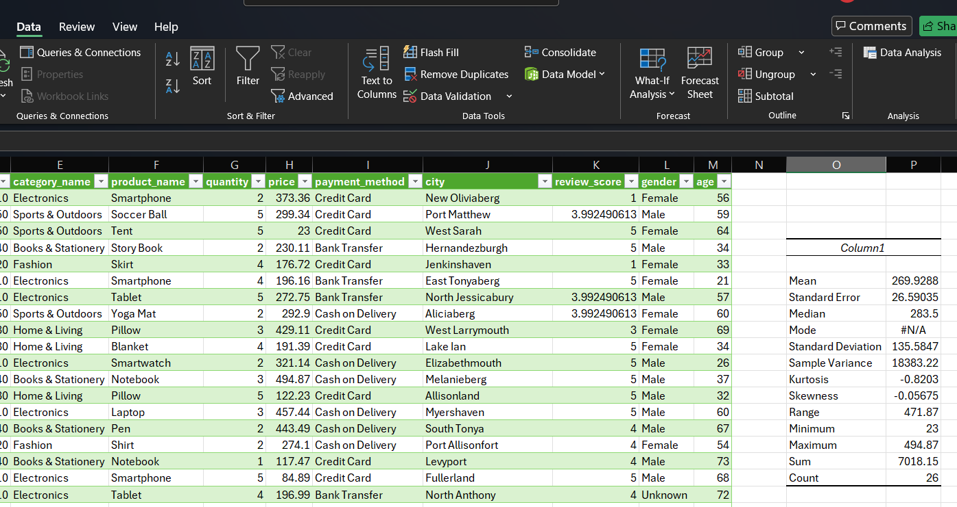

Data analysis tool pack is used to find the statistical terms in a single click, It will avoid the manual entry of the formulas in excel for each and every function.
STEPS:
Data Descriptive statistics select input range from the excel select output range from the excel click summary statistic then click ok.

This will be the final output.
Column1
Mean | 269.9288
Standard Error | 26.59035
Median | 283.5
Mode | #N/A
Standard Deviation | 135.5847
Sample Variance | 18383.22
Kurtosis | -0.8203
Skewness | -0.05675
Range | 471.87
Minimum | 23
Maximum | 494.87
Sum | 7018.15
Count | 26

There is no repeated values in the selected range , that’s why the mode value is #N/A.

- Use of Pivot Tables for advanced summarization

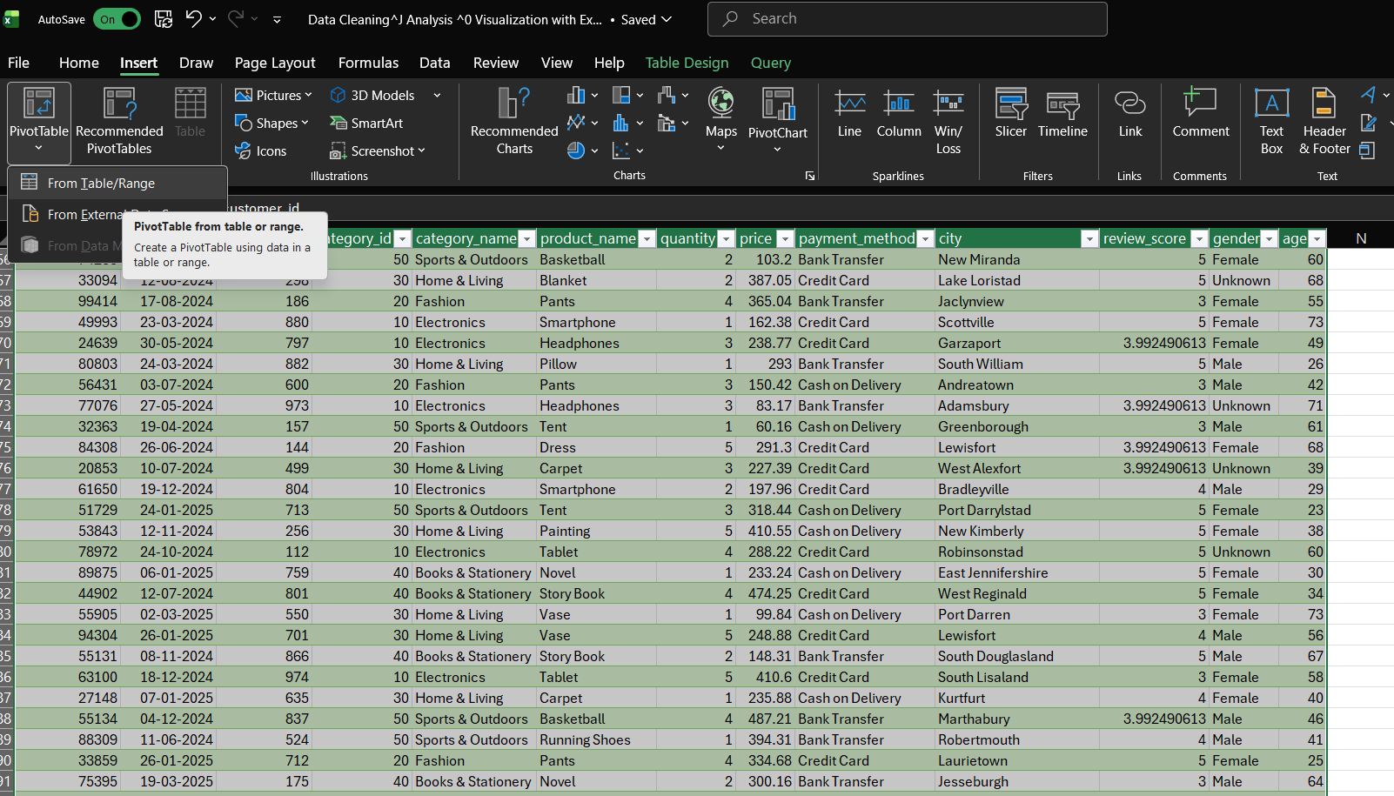
Steps:
Select the range of data Go to Insert Pivot Table From Table / Range New worksheet Ok
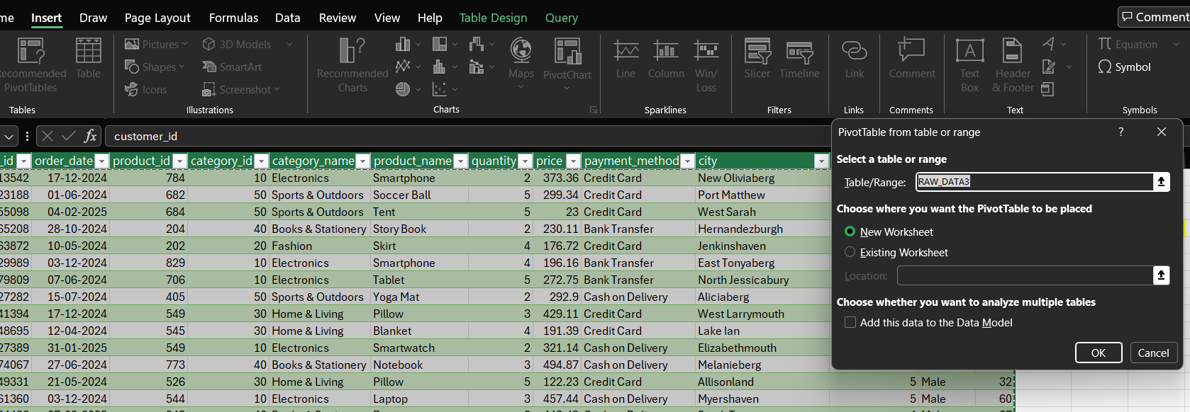
We can make insights based on our selection of the particular pivot table fields.
Gender – Sum of price
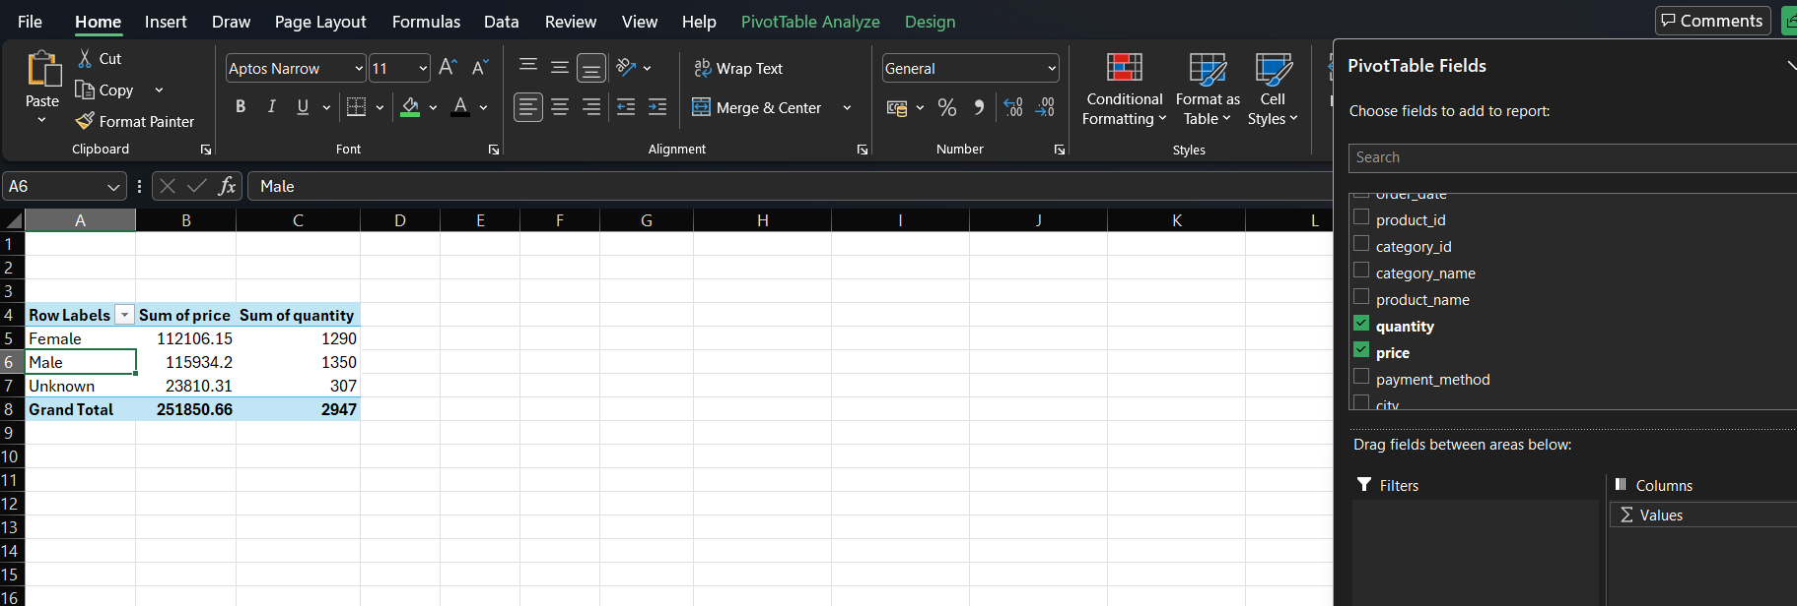
From this we can find gender wise difference in the purchase of items and their prices as well.
This will helps to find which gender is more purchasing the items from the company.

Year- Sum of quantity- Total price.
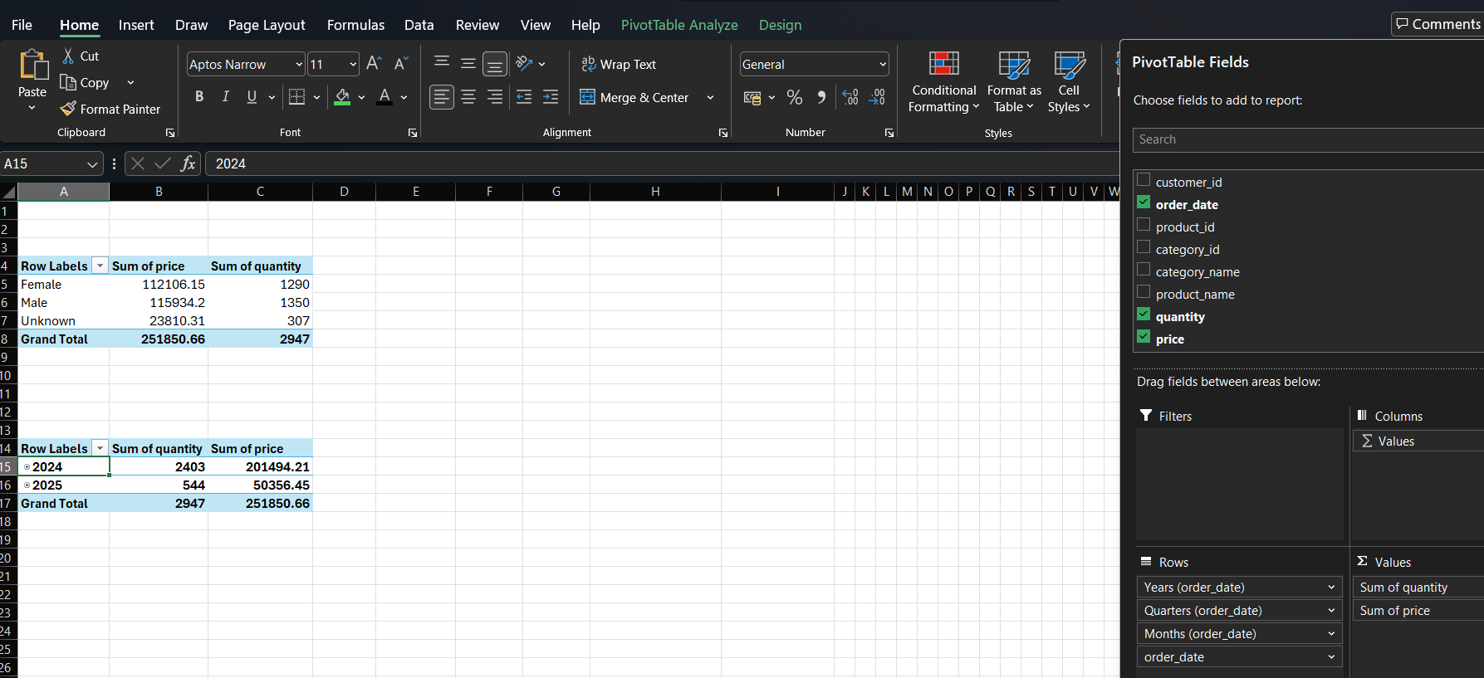
This will give yearly analysis, can compare the growth of the company and sale of the product.
Monthly sales of quantity and sum of price.
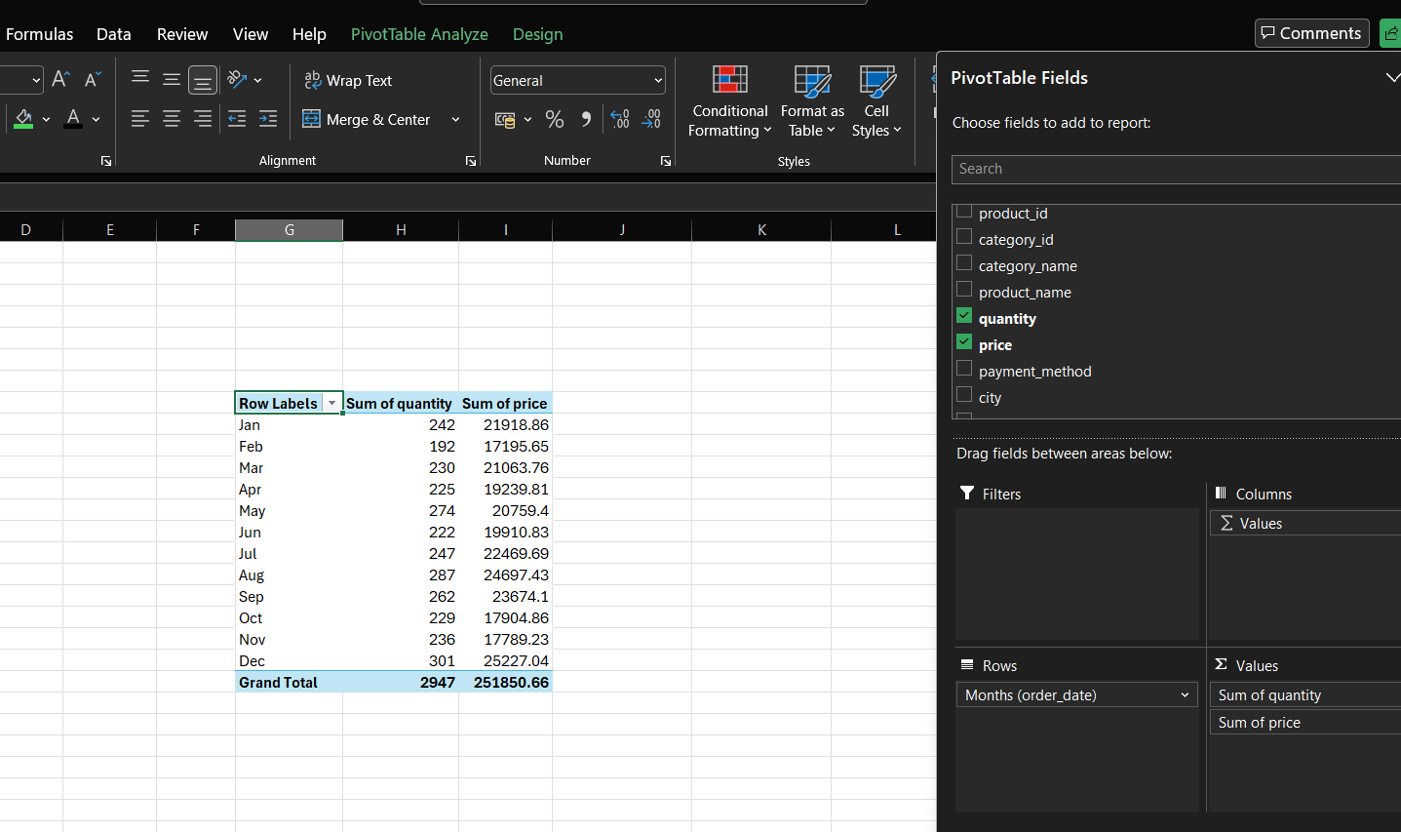
This will give an overview about the sales , and can make more profit when the sales of each product can analyse monthly.

Payment method-sum of price- sum of quantity.

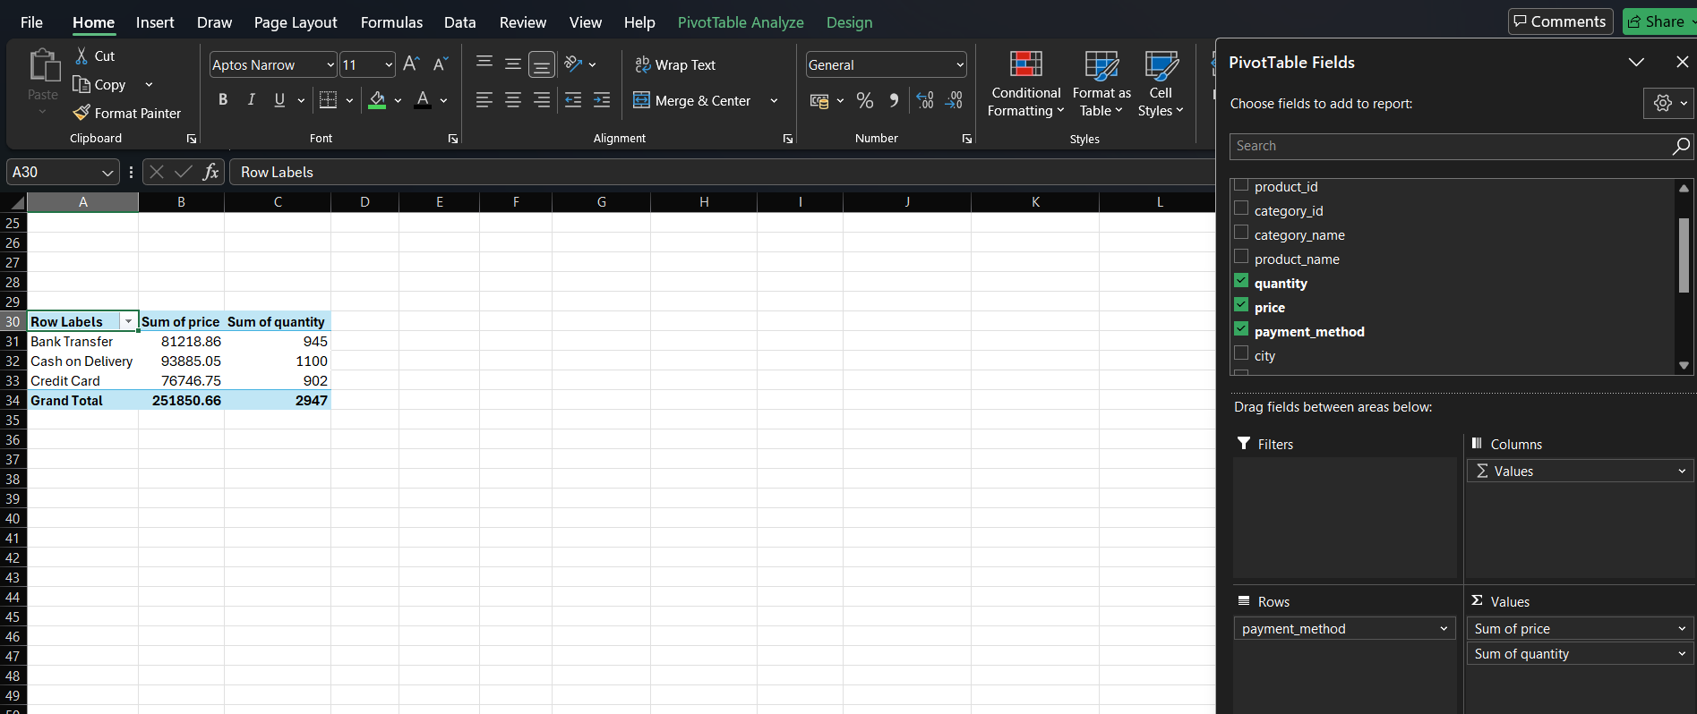
This will give an idea about the payment methods, and the cash flow through which medium.

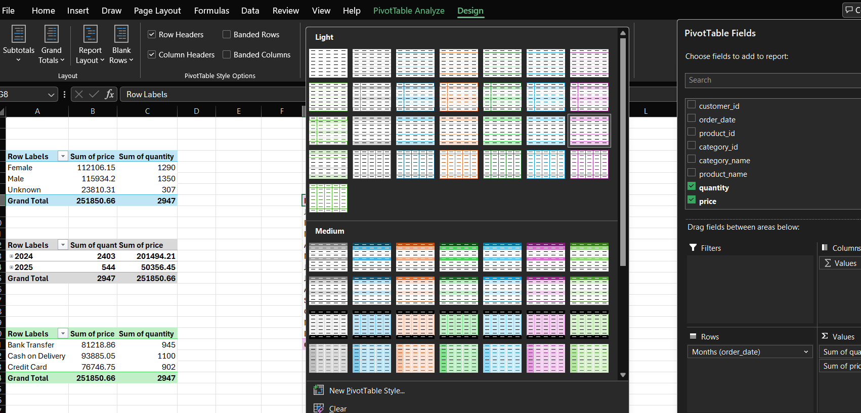

In Design tab we can choose the design for the table.

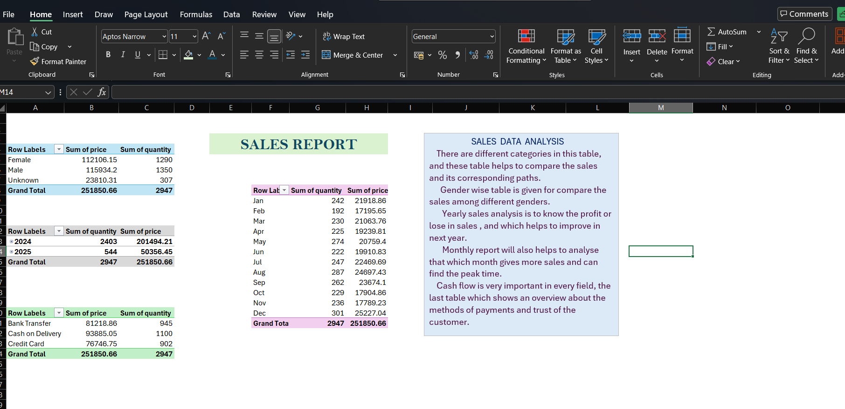

Data visualization: create at least three chart types, build an interactive dashboard, and use basic Pivot Charts.
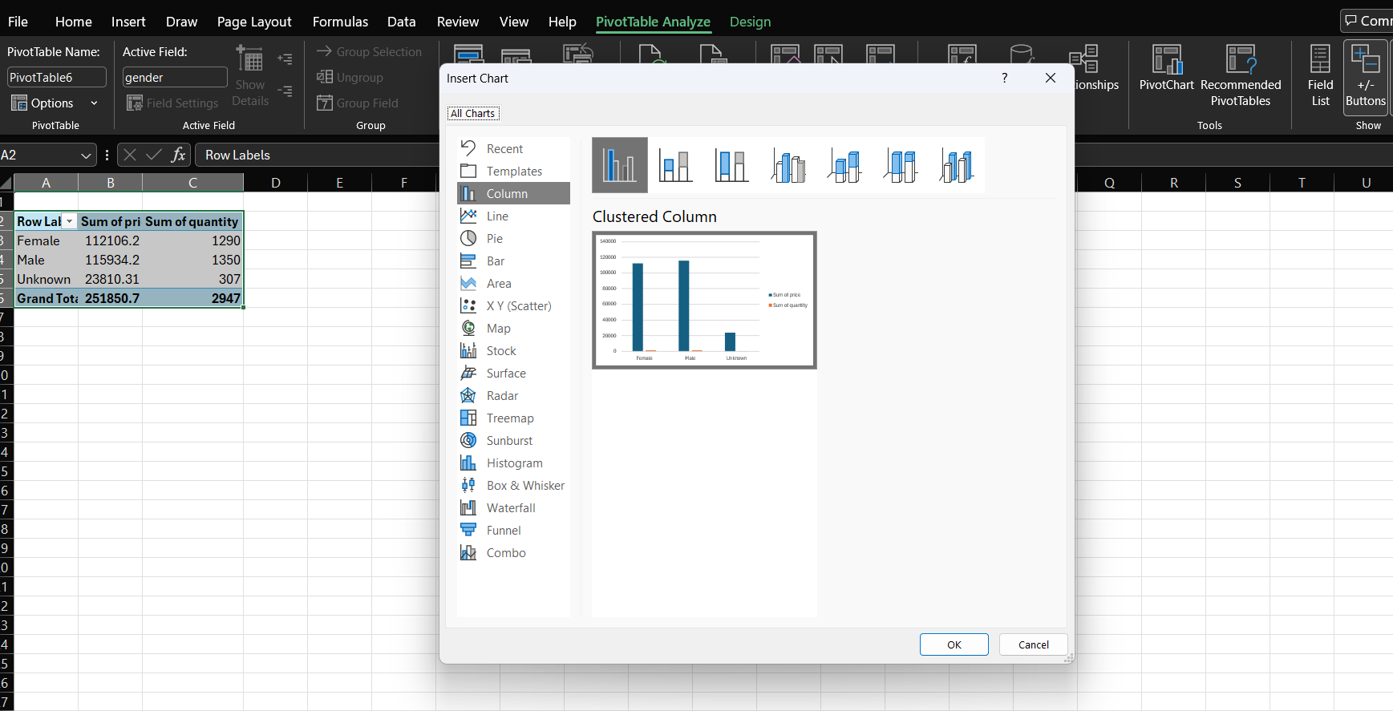
Pivot table Analyze Pivot chart Then choose the chart.
CLUSTERED COLUMN:
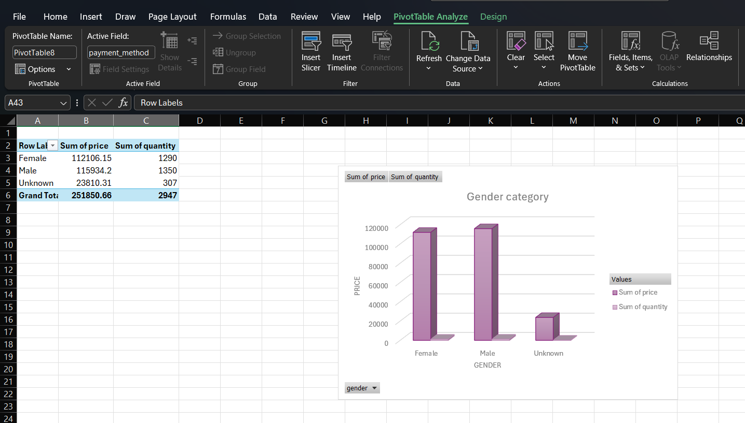
LINE CHART:
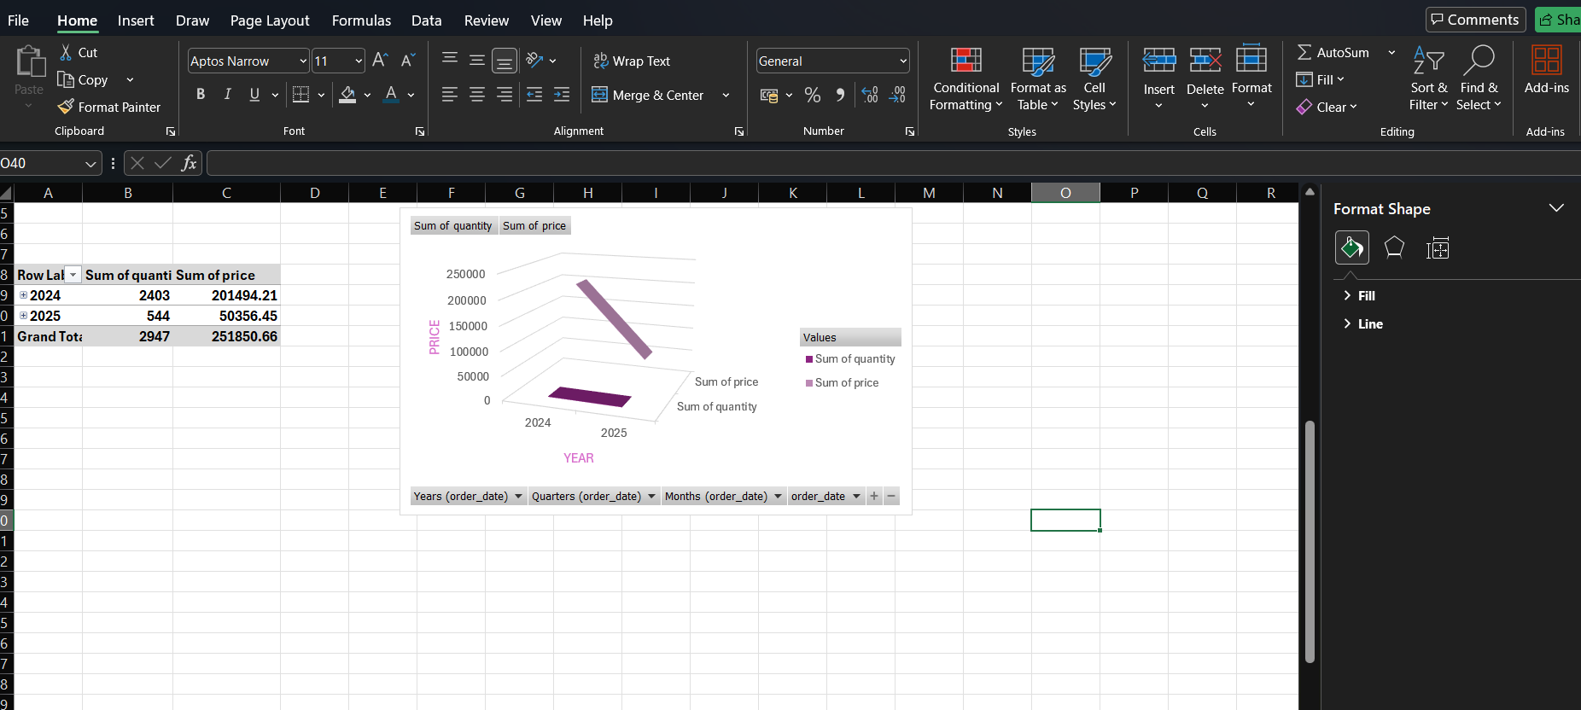
PIE CHART:

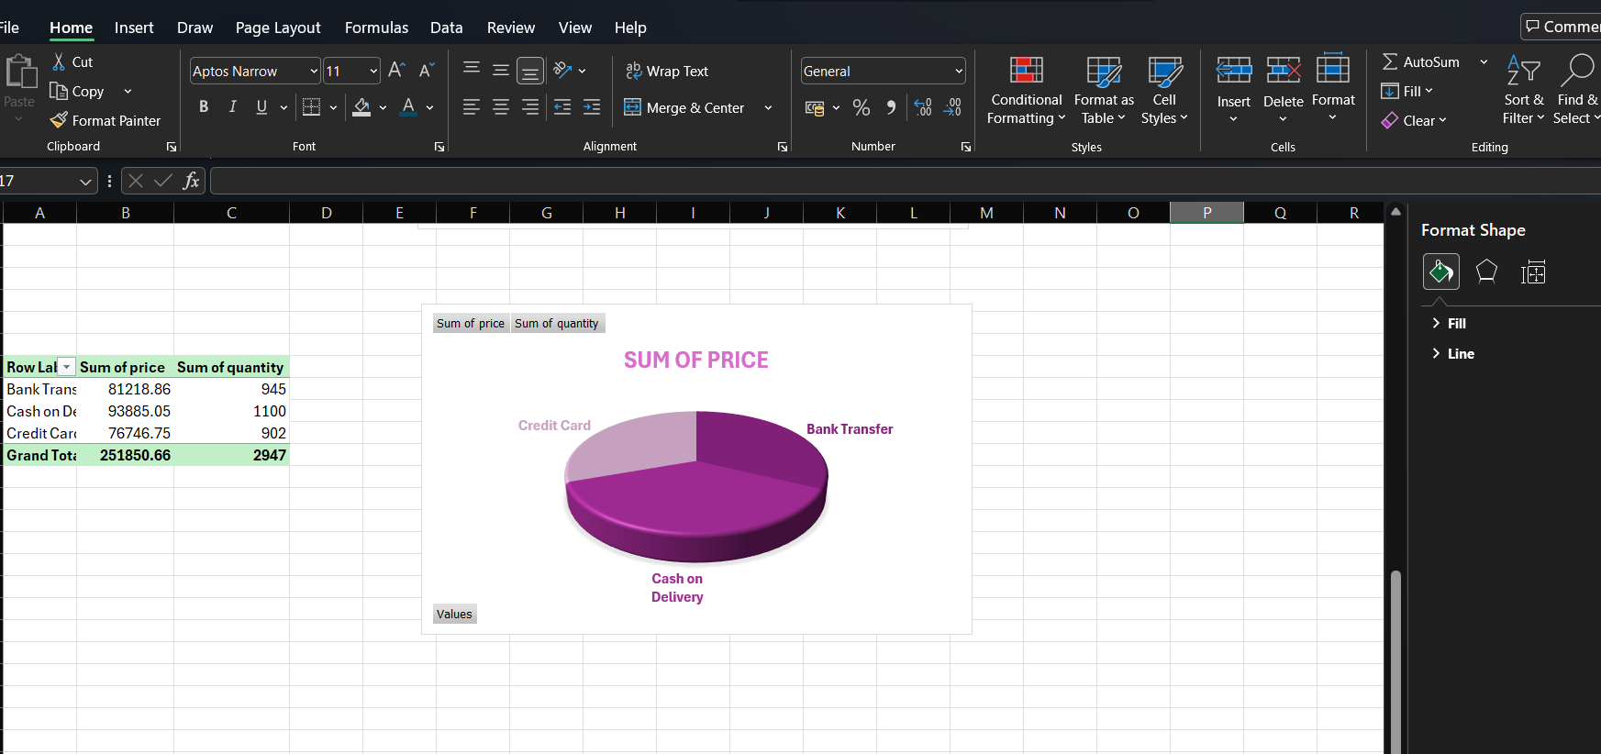

CLUSTERED BAR:
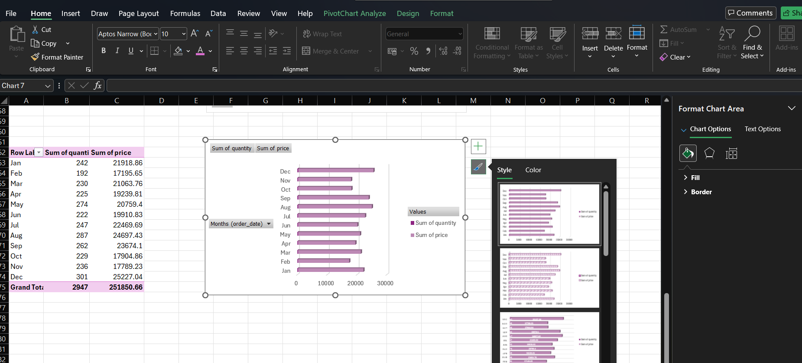
SLICER:
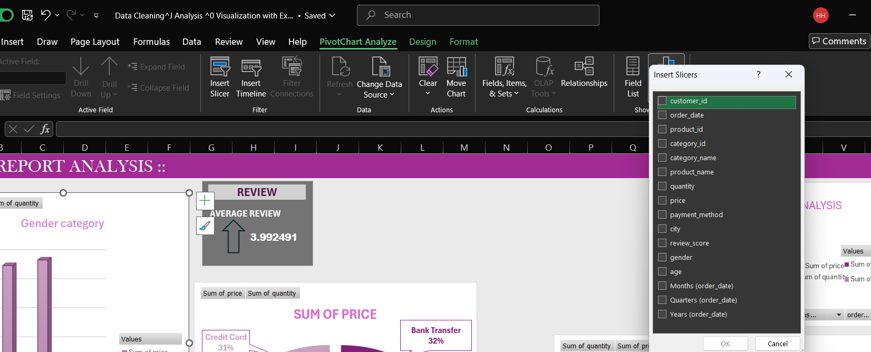
Connecting Tables:
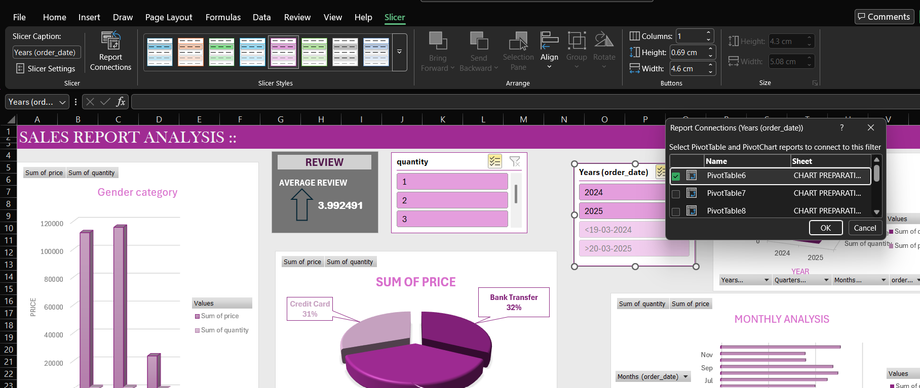

Final Dashboard:
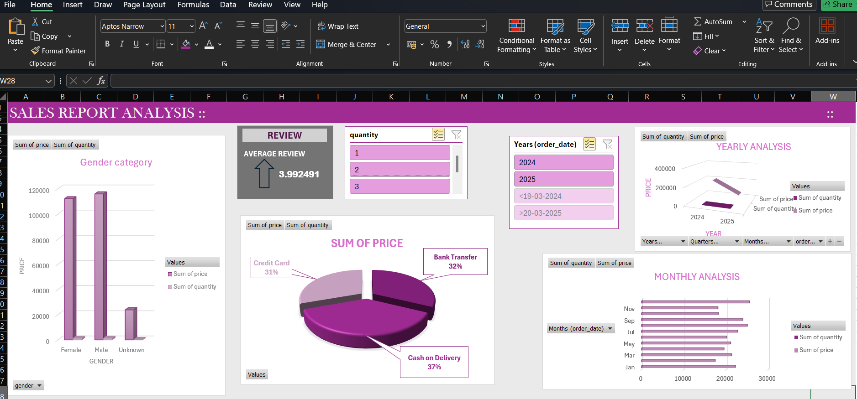

CLEAR FINDINGS & SUMMARY

The assignment focused on cleaning, analysing, and visualizing an E-commerce dataset using Excel tools to identify key business insights.
The E-commerce data set has duplicates, missing and inconsistent values, which makes the data inaccurate and cannot make insights from them. Before making any steps we have to clean the data first.
After importing the data to power query editor we can clean the data or delect the duplicate data.
Conditional formatting is one of the important steps, it will give an overview and differentiate the data according to the conditions we are applying.
In "Excel Formulas & Functions " SUMIF ,COUNTIF,AVERAGEIF,XLOOKUP & VLOOKUP Functions are basically used.
Data analysis tool pack is used to perform all the statistical formulas. Then ath the end of the assignment we are creating pivot tables , connecting those tables and making Bar ,column, pie charts and finally making the Dashboard.
This dashboard will give an overview about the whole assignment and about the dataset.

The final dataset will get a complete order and can find insights easily from that since it is fully cleaned and arranged in a neat format.
My findings are using XLOOKUP is far better than HLOOKUP & VLOOKUP, because XLOOKUP is the modified version and that finds the value with out any complex formulas. Also using analysis tool pack and in one click all the statistical data can create.
Dashboards will helps to explain the project easily. From the dashboard we can find the total sales and total quantity based on gender basis, yearly and monthly. Also which payment method is used by the customer mostly can find from this.
These data will helps the company to find their customer, and reach out them , can offer discounts and attract more customers. Gender wise classification will helps to find out the customer and that will helps to provide more products based on their interests. Always yearly analysis will helps to improve the company , that is also provided. Monthly analysis helps to identify the peak time in a year and can provide more offers on that time to attract the customers.

